**BRANCHES**

**TO START  
1.) Menu  
2.) Maintenance  
3.) Banks**

Branches

Maintenance

Menu

33 1*1*

2 1*1*

1 1*1*

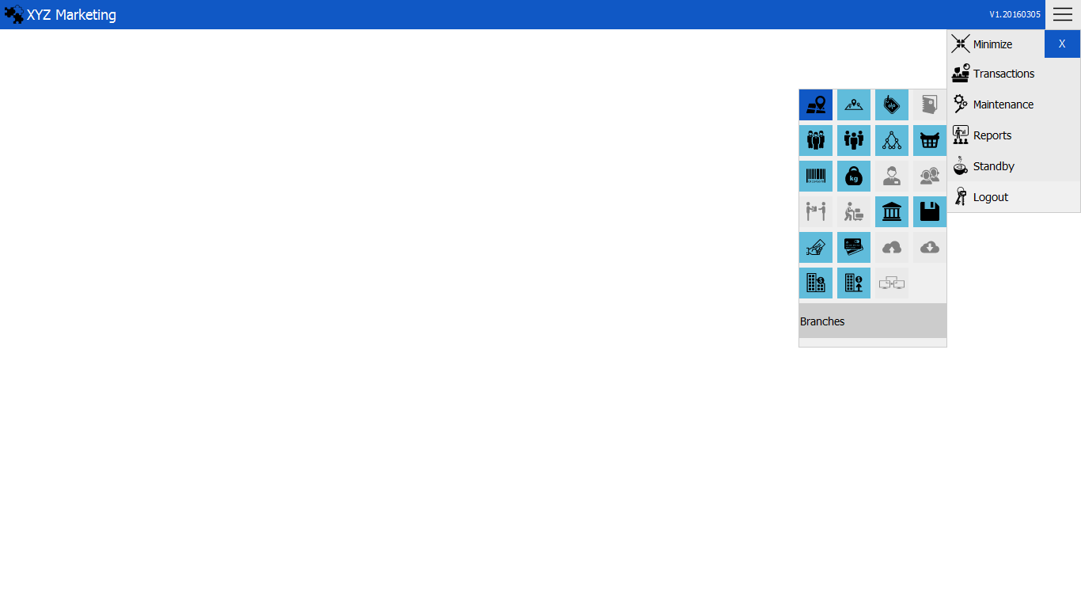

**NEW BRANCH  
1.) Input the new branch   
2.) Input the address of the branch  
3.) Add**

Add

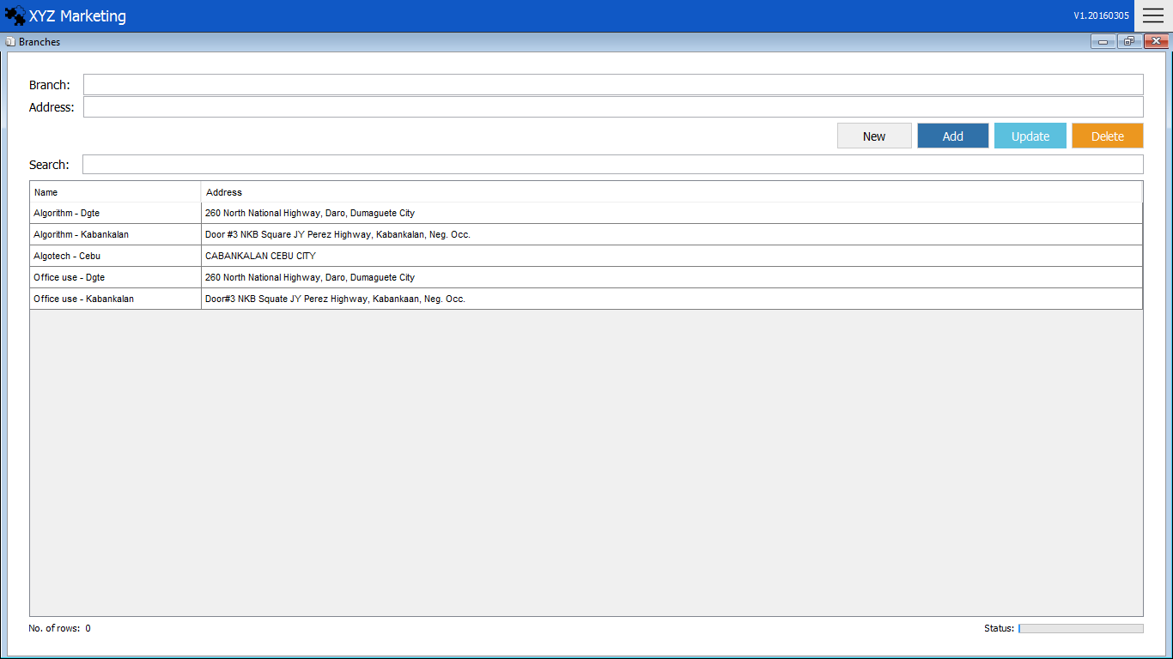

Branch List

Address

New branch

Search box

3 1*1*

2 1*1*

1 1*1*

**1.) Input the new branch**

Input the name of the new branch to be added.

 **2.) Input the address of the branch**

Input the address of the new branch.

**2.) Add,Update & Delete**

**2.1) Add**

After filling up the details, just click the add button to finish.

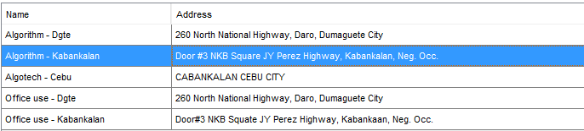**2.1) Update**

Click the name of the branch in the list that you want to update.



Click the update button to finish.

**2.2) Delete**



Click the delete button to finish.

Click the name of the branch that you want to delete.